# Water Tank Model and PI controller

In the following, we derive a model for how the fluid level in a tank varies depending on the inflow and outflow. The outline of the model can be found in Chapter 6 in [1].

The figure below shows a tank where the fluid level will vary in time depending on how much fluid that enters and leaves the tank. At the inlet, there is a pump that supplies water while at the bottom there is a valve where fluid leaves the tank. The opening of this valve can be varied between z = 0 (closed ) and z = 1 (fully open). The amount of flow of liquid across this valve will depend on the opening but also on differential pressure across the valve. This differential pressure will again depend on the fluid level h in the tank and the hydrostatic pressure that is exerted at the bottom of the tank.

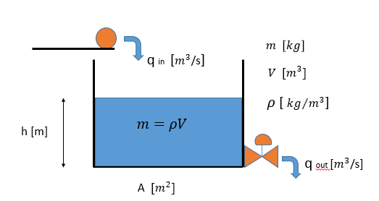

A basic assumption here is that the density of the fluid is the same all over in the tank. The model we derive is based on mass conservation principles. It should be noted that this model has similarity with models we often find in chemical engineering i.e. continuous stirred tank reactor (CSTR). In these models, one has a fluid but also some kind of chemical compound that is of interest. They can also be used for modelling pollution in lakes, But a major assumption is that the compound of interest is distributed uniformly in the system. For more information on CSTR models, check Chapter 7.2 in [2]

## Outline of Model

The model will be derived based on mass conservation principles. The amount of mass in a system will vary depending on how much flows in and flows out and eventual sink/source terms related to if mass was generated inside the tank itself. This will not be the case here but we can put the general balance law like this:

Change in mass in tank (kg/s) = inflow (kg/s) – ouflow (kg/s) +/- mass generated in the tank itself (kg/s)

One example of where one could have a sink/source terms is for instance if a phase transfer between liquid and gas was taking place e.g. due to boiling.

In our case, it will only be:

Change in mass in tank (kg/s) = inflow (kg/s) – ouflow (kg/s) +/- mass generated in the tank itself (kg/s)

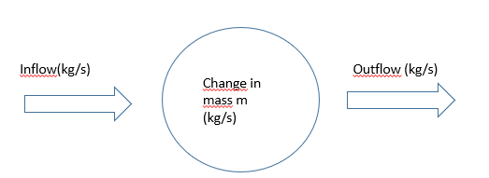

The mass flow rate in and out is found by multiplying the water density with the volumetric flow rate. For instance inflow( kg/s) = $ρq_{in}$. Here $ρ=1000 kg/m^{3}$ and qin has unit m3/s.

We can now formulate a first order differential equation with its initial condition:

$$\frac{dm}{dt}=ρq_{in}-ρq_{out}, m\left(0\right)=m_{0}$$

Here m is the mass of water in the tank (unit kg). t is time in seconds. The initial mass of water in the tank at time zero is m0.

Note that the mass $m=ρV=ρAh$ where A is the ground area of the tank while h is the water level in the tank. One can therefore write: $\frac{dm(t)}{dt}=\frac{d\left(ρAh\left(t\right)\right)}{dt}=ρA\frac{d h(t)}{dt}$

The height of the fluid level h will vary in time depending on how much flows in and out. Our differential equation now reads:

$ρA\frac{d h(t)}{dt}=ρq_{in}-ρq_{out}$, $h\left(0\right)=h_{0}$

We can delete $ρ$ from the equations since we assumed that the density was the same all over in the tank. We can also divide by area:

$\frac{d h(t)}{dt}=\frac{1}{A}(q_{in}-q_{out})$, $h\left(0\right)=h_{0}$

We will now model the outflow qout in more detail where we will employ a valve equation which links the volumetric flow rate across the valve with the differential pressure across the valve, valve opening z and other characteristics. The equation can be found on page 108 in [1]

$q_{out}=K_{v}(z)\sqrt{\frac{p_{v}}{G}}$. Here G is the fluid density relative to water. In this case it will be 1.

$K_{v}\left(z\right)$ is a constant related to the valve. We will assume a linear valve characteristic $K_{v}\left(z\right)=kz$ where *k* is a constant and z is the valve opening that varies from 0 (closed) to 1 (fully open). The differential pressure across the valve is the difference between the pressure at the inlet of the valve and the pressure at the outlet of the valve.

The pressure at the inlet of the valve is the atmospheric pressure above the tank plus the hydrostatic pressure of the water column of height h.

$p_{tankbottom}=ρgh+p_{atm}$, here g is the gravitational acceleration.

The pressure at the outlet of the valve is also atmospheric $p_{atm}$

Hence the differential pressure across the valve becomes:

$p_{v}=ρgh\left(t\right)+p_{atm}-p_{atm}=ρgh(t)$

Note that when Patm is included, we talk about the absolute pressure. When patm is removed as we e.g. have for the pressure differential, we talk about gauge pressure.

The valve equation can now be written:

$q_{out}=kz\sqrt{ρgh\left(t\right)}=k\sqrt{ρ} z\sqrt{gh(t)}=k_{eff}z\sqrt{gh(t)}$.

From this we see that the flowrate out depends on the valve opening z which is a parameter we can control to adjust the fluid level. In addition, it depends on the height of the fluid level h(t)

The final differential equation then becomes:

, h(0) = h0

## Model Parameters and Numbers

The following data will be used for the water tank model:

A = 4 m2  (ground area of tank)

h0 = 2 m (initial water level)

k = 0.002

g = 9.81 m/s2 gravitational acceleration

qin = 0.03333 m3/s initial flow rate in (this one can change in time)

z = 0.12 This is the initial valve opening. This is also a parameter that will be changed in time.

On next page we will show the code. This can also be downloaded from CANVAS. Here one can note that the Euler method is used to simulated forward in time how the water level h(t) varies in time. A small timestep dt = 1 second has been chosen.

Note that for this model, it is not easy and maybe not possible to derive an exact solution. We note that the 1st order differential equation is nonlinear since h(t) occurs under a root. In addition, we want to be able to change qin and z as function of time and then it is convenient to develop a simulator using a numerical method where we can play with different scenarios.

## Euler method

The differential equation reads;

, h(0) = h0

The right hand side can be defined as f(h,qinn,z):

$\frac{dh}{dt}=$ f(h,qinn,z)

The Euler method will then be:

$h_{new}=h_{old}+f(h_{old},q_{inn,old},z_{old})∆t$ or using indexes:

$h_{k+1}=h_{k}+f(h_{k},q_{inn,k},z_{k})∆t$, $h_{0}=2m$

## Starting Code

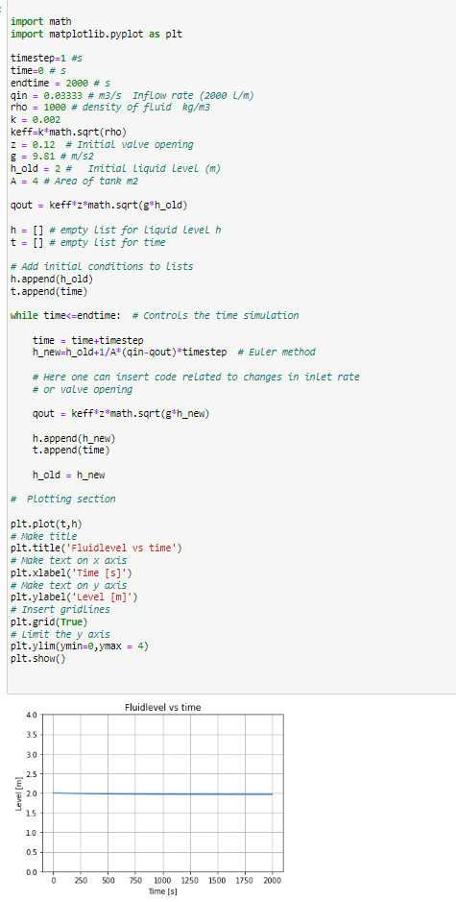

## Control Engineering and PI Controller

A PID (Proportional, Integral and Derivative) controller can be used to regulate different types of systems/processes where one wants to control a certain variable to stay at a fixed level [1]. It is much used in different industries to control processes. One example can e.g. be when one try to bring unstable renewable energy resources like wind and solar into the electric grid. Then one need to control that the frequency of the electric grid remains stable by compensating with a stable energy resource like e.g. hydropower or a nuclear power plant. Other examples can be temperature regulation of a system, dynamic positioning of a ship [1]. In drilling, it can be used for controlling the pressure at the bottom of the well at a fixed level to avoid drilling fluid losses or inflow of gas (kicks).

In the following, we will use a PI controller (D skipped) to show how we can control the water level in the tank to be remain at a fixed level. The fixed level we want keep is called the setpoint $h_{setpoint}$. The process variable that we want to bring close to the setpoint is the fluid level ***h*** in the tank. This can also be called the controlled variable or the measured variable.

The process disturbance variable that can affect the level in the tank is the flow rate in $q_{in}$. The variable we use to control the water level is called the control variable. In this case, this will be the opening of the valve ***z*** that can take values in the range [0,1].

If we e.g. increase the inflow, the level will increase and we need to compensate this by increasing the valve opening if we want to maintain the same fluid level. If we choose to change the setpoint itself to e.g a lower level but leaves the inlet unchanged, the valve opening needs to be increased temporarily. Hence, both process disturbances and changes in setpoint will lead to that the regulation must bring the system back into a stable situation where the setpoint is kept.

The following figure tries to illustrate the terminology and workflow:

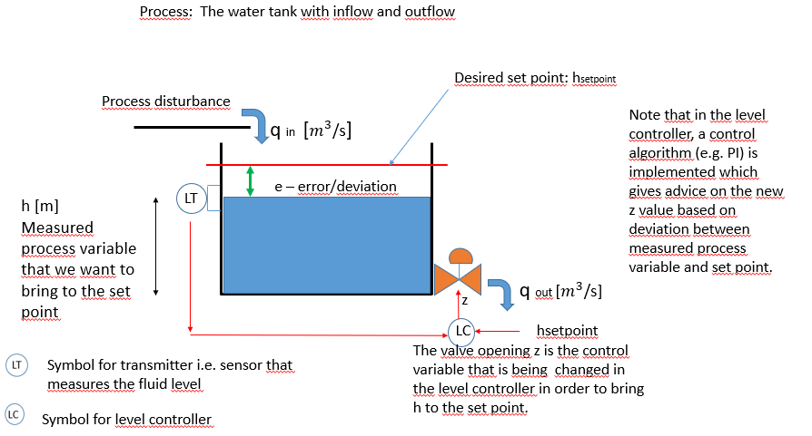

PID controllers are typically used on measured data. However, in our case, the simulator we have developed will be used instead of having a physical experiment with a water tank. The simulator becomes what we call a “*digital twin*” of the real process. The simulated water level ***h*** will represent the measured value.

The error (deviation) at timelevel ***tk+1*** between the simulated/measured value for the water level ***h***and the setpoint $h_{setpoint}$ is defined as:

$$e\left(t_{k+1}\right)=h_{k+1}-h_{setpoint}$$

We will use a time discrete PI controller such that the new valve opening at time *tk+1* is given by the following formula:

$$z\left(t_{k+1}\right)=z\left(t_{k}\right)+K_{p}(e\left(t_{k+1}\right)-e\left(t_{k} \right))+K_{i}e(t_{k+1})∆t$$

Here the proportional gain parameter ***Kp***and the integral gain parameter ***Ki*** are parameters that must be fitted for the process being controlled. There are different algorithms available to determine the optimal value for these [1]. We will not go into details about these algorithms, and we are therefore given these parameters to be $K_{p}=3.0 and K_{i}=0.3.$ The timestep $∆t$ will for simplicity be the same as the timestep used in the simulator developed, i.e. $∆t=1s.$

## References

[1] Haugen, F.A. 2014 Reguleringsteknikk 2 Utgave

[2] Hiorth, A. 2023. Modelling and Computational Engineering. <https://github.com/ahiorth/CompEngineering/blob/master/book.pdf>

[3] Nygaard, G and Godhavn, J.M. Automated Drilling Operations. 2013. UIS, NTNU.